DESIGN TASK
ECA5604-5G/6G COMMUNICATION SYSTEMS
NAME: V Sadhana
REG NO: 192412242
17. LEO Satellite-Assisted Communication Model
Aim: To model a LEO satellite-assisted wireless communication system and analyze the variation of received signal strength with distance.
Matlab Code:
clc;
clear;
close all;

% LEO Satellite Communication Model
h = 550; % LEO altitude (km)
R = 6371; % Earth radius (km)
fc = 2e9; % Frequency (Hz)
c = 3e8; % Speed of light (m/s)
Pt = 30; % Transmit power (dBm)
Gt = 20; % Transmitter antenna gain (dBi)
Gr = 20; % Receiver antenna gain (dBi)

% Ground coverage distance
d = linspace(550,1500,100); % km
d_m = d*1000;

% Free-space path loss
FSPL = 20*log10(d_m) + 20*log10(fc) ...
+ 20*log10(4*pi/c);

% Received power
Pr = Pt + Gt + Gr - FSPL;

% Plot
plot(d,Pr,'LineWidth',2);
grid on;
xlabel('Satellite-Ground Distance (km)');
ylabel('Received Power (dBm)');
title('LEO Satellite-Assisted Communication');
Output:
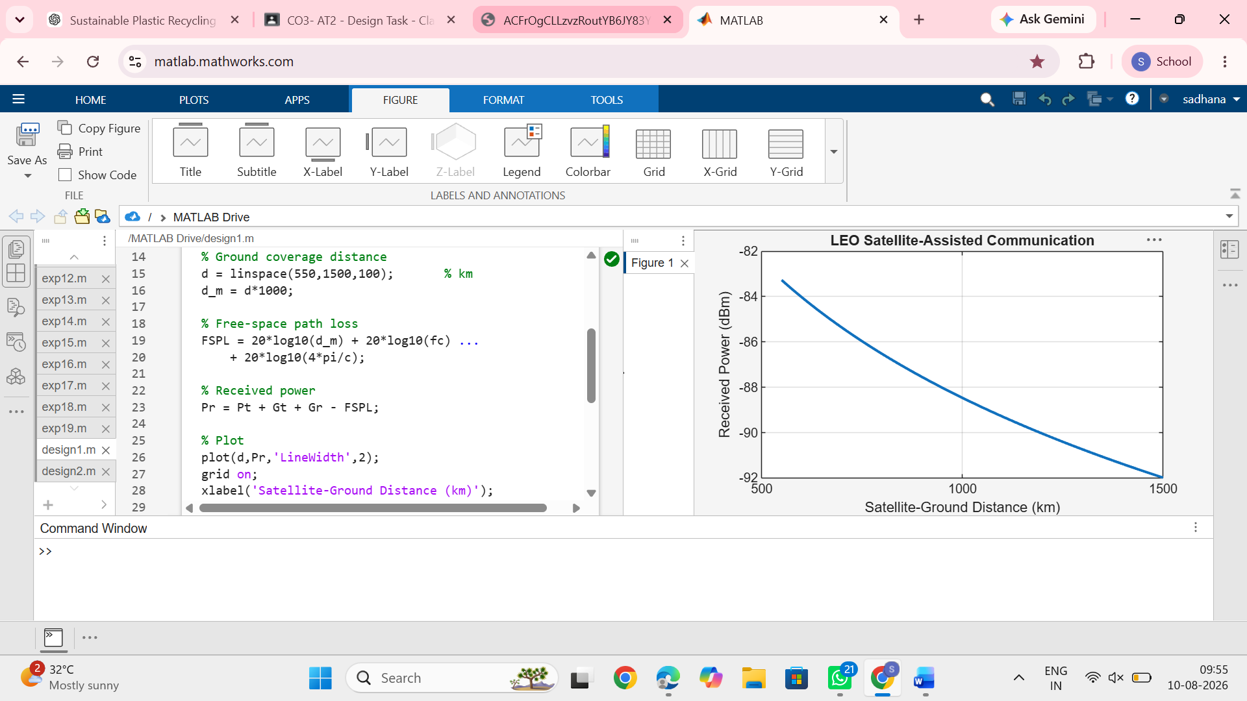
Result: The graph shows that received power decreases as the LEO satellite-ground distance increases, demonstrating the effect of free-space path loss.
18. Comparative Architecture of LEO, MEO and GEO Backhaul Systems
Aim: To compare LEO, MEO and GEO satellite backhaul systems based on propagation delay.
Matlab Code:
clc;
clear;
close all;

% Satellite altitudes
altitude = [550 10000 35786]; % km

% Speed of light
c = 3e5; % km/s

% Approximate one-way propagation delay
delay = altitude/c*1000; % ms

% Plot
bar(delay);
grid on;

set(gca,'XTickLabel',{'LEO','MEO','GEO'});
xlabel('Satellite Type');
ylabel('One-Way Propagation Delay (ms)');
title('Comparison of LEO, MEO and GEO Backhaul Systems');

% Display values
disp('Satellite Altitude(km) Delay(ms)');
disp([altitude' delay']);
Output:
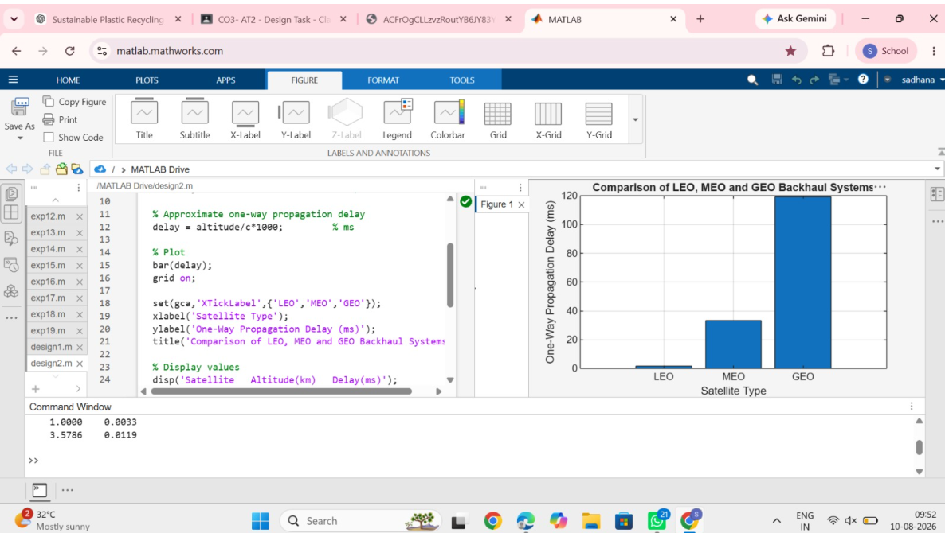
Result: The graph compares propagation delay. LEO has the lowest delay, MEO has moderate delay, and GEO has the highest delay because of its much greater orbital altitude.
Quick comparison
Satellite | Approx. Altitude | Relative Delay | Coverage
LEO | 550 km | Very Low | Small
MEO | 10,000 km | Medium | Medium
GEO | 35,786 km | High | Very Large

